Department | AIML
Course Code / Course Name | DSA0602/ Data Handling and Visualization
Experiment | Data Visualization using R
Name | YASHIKA.R
Register Number | 192525102
Date | 20/10/2026
Day | Tuesday
SET 25

Experiment 1: Line chart in Tableau
Aim: To visualize the trend in website page views over time using a line chart in Tableau.
Algorithm:
- Prepare the dataset with Date, Page Views, and Click-through Rate.
- Import the data into Tableau.
- Drag Date to Columns and Page Views to Rows.
- Select Line Chart from the Marks card.
- Add the chart title and axis labels.
Procedure:
- Save the data as Website_Traffic.csv.
- Open Tableau and connect to the CSV file.
- Set Date to the Date data type.
- Drag Date to Columns and Page Views to Rows.
- Select the Line mark type and format the title.
Output: A line chart showing daily page views from January 1 to January 5, 2023.
Experiment 2: Bar chart of the top N click-through rates in R
Aim: To display the days with the highest click-through rates using a bar chart.
Algorithm:
- Create the website traffic dataset.
- Sort the records by click-through rate in descending order.
- Select the top three days.
- Plot a bar chart with date labels and percentages.

# Set 25 - Top 3 Click-through Rates

library(ggplot2)

traffic <- data.frame(
Date = as.Date(c(
"2023-01-01", "2023-01-02", "2023-01-03",
"2023-01-04", "2023-01-05"
)),
Page_Views = c(1500, 1600, 1400, 1650, 1800),
CTR = c(2.3, 2.7, 2.0, 2.4, 2.6)
)

top_days <- traffic[order(-traffic$CTR), ][1:3, ]

ggplot(top_days,
aes(x = factor(Date), y = CTR, fill = factor(Date))) +
geom_col() +
geom_text(aes(label = paste0(CTR, "%")),
vjust = -0.4) +
labs(
title = "Top 3 Days by Click-through Rate",
x = "Date",
y = "Click-through Rate (%)",
fill = "Date"
) +
theme_minimal() +
theme(legend.position = "none")
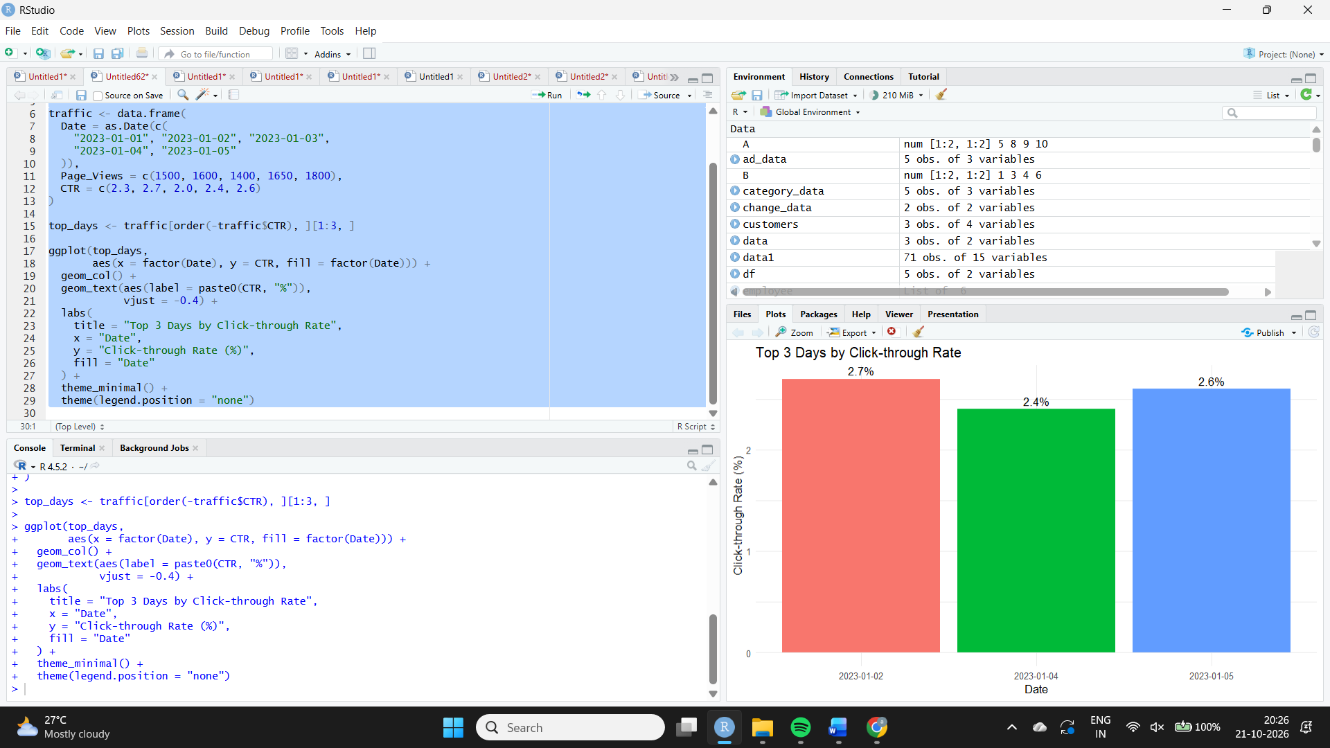
Output:
The chart displays these three days in descending order:
Date | Click-through rate
2023-01-02 | 2.7%
2023-01-05 | 2.6%
2023-01-04 | 2.4%
Result: January 2 has the highest click-through rate at 2.7%.
Experiment 3: Stacked area chart of user interactions
Aim: To visualize the distribution of likes, shares, and comments over time.
Algorithm:
- Create a dataset containing dates and interaction counts.
- Reshape the data into long format.
- Use geom_area() with stacking enabled.
- Label the axes and provide a legend.
Code
library(ggplot2)
library(tidyr)

interactions <- data.frame(
Date = as.Date(c(
"2023-01-01", "2023-01-02", "2023-01-03",
"2023-01-04", "2023-01-05"
)),
Likes = c(120, 150, 110, 160, 180),
Shares = c(40, 50, 35, 55, 65),
Comments = c(25, 30, 20, 35, 40)
)

long_data <- pivot_longer(
interactions,
cols = c(Likes, Shares, Comments),
names_to = "Interaction",
values_to = "Count"
)

ggplot(long_data,
aes(x = Date, y = Count, fill = Interaction)) +
geom_area(position = "stack") +
labs(
title = "Website User Interactions Over Time",
x = "Date",
y = "Number of Interactions",
fill = "Interaction Type"
) +
theme_minimal()
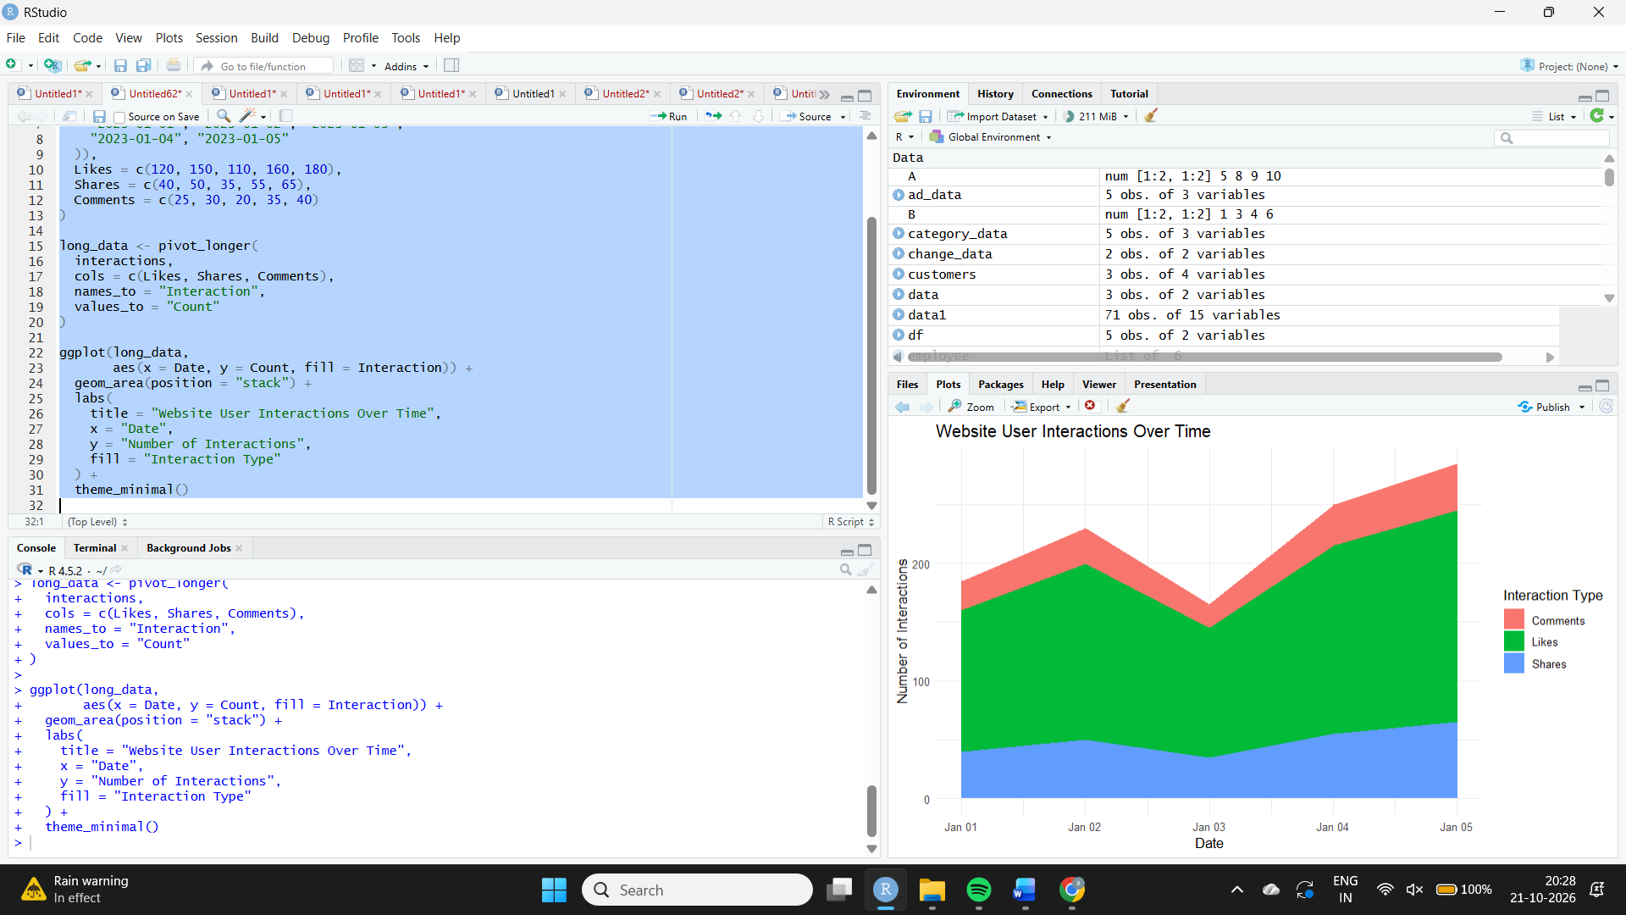
Output: A stacked area chart showing illustrative likes, shares, and comments for five days.
Experiment 4: Interactive Tableau dashboard
Aim: To create an interactive dashboard showing traffic sources on a map and page views by source.
Algorithm and procedure:
- Import a traffic-source dataset containing Source, Location, Latitude, Longitude, and Page Views.
- Create a map using Latitude and Longitude.
- Place Source on Detail and Page Views on Size or Color.
- Create a bar chart with Source on Columns and Page Views on Rows.
- Combine both worksheets in a dashboard.
- Enable Use as Filter so selecting a map mark filters the bar chart.
- Add tooltips and a clear dashboard title.
Output: An interactive map and a bar chart that respond to source selection.
Result: The dashboard allows users to compare page views across traffic sources and geographic locations. The provided dataset does not contain source or location information, so these fields must be obtained separately before the map can show real results.

